**SmartCrop: -AI-Driven Solutions for Enhanced Polyhouse Farming**

Yash Yadnyeshwar Shirgaonkar

28/07/2024

*Abstract: -*

This Project is an innovative AI-driven solution designed for polyhouse farming by leveraging Data Science, Machine Learning (ML), and Artificial Intelligence (AI) technologies. Polyhouse farming involves growing crops in a controlled environment, which can significantly enhance yield and quality. Our platform aims to optimize crop yield, enhance resource efficiency, and reduce operational costs for small, medium and large-sized polyhouse farms intended for commercial use. By integrating IoT sensors, predictive analytics, and machine learning models, this platform provides real-time insights and actionable recommendations to farmers, fostering sustainable and profitable agricultural practices.

**1. Problem Statement**

Introduction: -

As technology evolves with each passing day, agriculture is also developing. India has always been an agriculturally dominated country with suitable subtropical climatic conditions to do good agriculture. Although in recent years, the efficiency of crop production and the total turnover have reduced than usual times, people have faced many losses. Earlier it was believed that traditional methods for crop production were enough, but now, consumers have started demanding off-season yields.

After keeping these things in mind, a new technology was developed that could help in reducing the losses by achieving better profits and higher production in the same or lesser investment. This common solution is known as polyhouse farming. Polyhouse farming is a renowned modern method of farming that is gaining a lot of popularity in countries like India and Bangladesh. Polyhouse is designed to evolve the traditional strategy of farming that can bring more new opportunities for better yield and profit while using lesser resources.

Traditionally, greenhouse farming relied heavily on human expertise to maintain optimal growing conditions. Factors like temperature, humidity, light levels, and irrigation all needed constant monitoring and adjustments. Increasing Human intervention and affecting the crops if neglected, incurring losses.

In this project I am going to use AI, ML with IoT integration for Data Analytics, Predictive Modelling and Automated Decision-Making. It will help to create and maintain the environment within the polyhouse with minimal to no human intervention. It will reduce the human labour recurring cost significantly with one time installation investment.

Polyhouse farmers in India face several challenges:

1. **Climate Control:** Maintaining optimal temperature, humidity, and CO2 levels is critical but difficult without automated systems.
2. **Pest and Disease Management:** Early detection and control of pests and diseases can prevent significant crop losses.
3. **Resource Management:** Efficient use of water, fertilizers, and energy is essential to minimize costs and environmental impact.
4. **Market Predictability:** Fluctuating market prices and demand can affect profitability.
5. **Lack of Real-time Monitoring:** Difficulty in tracking plant health and environmental conditions continuously.
6. **Suboptimal Crop Yield:** Inability to predict and maximize crop yield due to limited data-driven insights.
7. **High Operational Costs:** Inefficient processes leading to increased labour and resource costs.

**2.0 Market/Customer/Business Need Assessment: -**

**2.1 Market Need Assessment**

Global Food is one of the basic human need to live life. As rapidly increasing population there is need for increment is food production. According to the Food and Agriculture Organization (FAO) of the United Nations: By 2050, global agricultural production will need to increase by about 60% compared to 2007 levels to meet the food demand of the projected population. Taking into consideration the climate change and global warming causing harm to food production there is a need for food production in controlled environment for best quality and increased yield using polyhouse. For Further quality betterment and better environment control there is need for automation and data-driven decisions.

India Specific: - Due to imbalance in nature there have been a lot of cases of farmers asking for reimbursement from government due to the losses caused by natural phenomenon (such as heavy rain, no rain(when rain is needed), unpredicted sudden rainfall). The losses can be prevented using polyhouse. And resources like water supply, fertilizers, pesticides, etc. can be saved using automation providing only when needed with exact amount needed.

**2.2 Customer Need Assessment: -**

Consumers are demanding high quality agricultural products, and the demand for off-season yields is also increasing. Therefore, the producers (our customers) need to get higher yields with high quality, which is not always guaranteed if they follow traditional open-field farming methods which is highly dependent upon nature. But this needs can be satisfied using polyhouse for controlling environment and automation using AI, ML & IoT for increasing yield up to 3-4 times (varying with different crops) with 30-50% less resources. The quality of the yield will be high increasing its price & the off-season harvest will have high price in the market increasing the profit even further for the farmer.

**2.3 Business Need Assessment: -**

**2.3.1. Partnerships: -**

* Partnership with IoT manufacturing Company
* Partnership with Polyhouse Construction Company

In this project I will be making a polyhouse automation Platform using AI, ML & IoT. I will need to make partnerships with the IoT manufacturing factory for IoT parts and Polyhouse construction Services who can help us with constructing polyhouse.

**2.3.2 Technological Infrastructure: -**

**IoT Sensor Network**

* Installation of sensors to collect data on soil, weather, and plant conditions.
* Wireless communication protocols (e.g., LoRa, Zigbee) for data transmission to a central server.

**Data Processing and Storage**

* Cloud-based infrastructure for storing and processing large volumes of sensor data.
* Data pre-processing techniques to clean and normalize data for analysis.

**Machine Learning Models**

* Supervised learning models for yield prediction and disease detection.
* Reinforcement learning for optimizing irrigation and fertilization schedules.

**AI Algorithms**

* Predictive algorithms to forecast environmental changes and their impact on crops.
* Prescriptive algorithms to provide actionable recommendations to farmers.

**2.3.3 Marketing**

• Partnerships: Collaborations with agricultural organizations and government bodies to promote SmartCrop.

• Education and Training: Workshops and training sessions for farmers on the benefits of AI-driven farming.

• Digital Marketing: Online campaigns targeting farmers and agribusiness stakeholders.

**3.0 Target Specifications and Characterization: -**

**3.1. Commercial Farmers and Agribusinesses**

* Large-Scale Farmers: Those who manage extensive agricultural operations and are looking to improve yield, efficiency, and profitability.\
* Specialty Crop Producers: Farmers growing high-value crops like tomatoes, cucumbers, strawberries, and flowers that benefit significantly from controlled environments.
* Cooperatives and Farmer Groups: Groups that pool resources and invest collectively in infrastructure to improve overall productivity.

**3.2. Government and Non-Governmental Organizations (NGOs)**

* Government Agricultural Departments: Agencies looking to promote modern agricultural practices among farmers.
* Development NGOs: Organizations working on food security, sustainability, and rural development projects.

**3.3. Horticulturists and Floriculturists**

* Flower and Ornamental Plant Growers: Businesses specializing in the cultivation of flowers and ornamental plants which require controlled environments.
* Nurseries and Garden Centers: Enterprises that need to grow and maintain a variety of plants for sale.

**3.4. Investors and Agritech Companies**

* Agritech Start-ups: Companies developing IoT solutions for agriculture who need demonstration and testing facilities.
* Venture Capitalists and Investors: Individuals or firms investing in innovative agricultural solutions and infrastructure projects.

**3.5. Export-Oriented Farmers**

* Exporters of High-Value Crops: Farmers and agribusinesses focusing on producing crops for export markets where quality and consistency are critical.

**4.0 External Search**

* The information available in this report are all taken from external sources such as online articles, websites, YouTube, academic journals, research papers, Government Sites, ChatGPT and many more were used for researched.

**5.0 Bench marking alternate products: -**

**5.1. Fasal**

* **Overview**: Fasal is an India-based agro-tech start-up that provides AI-driven solutions for precision agriculture.
* **Features**:
  + Real-time monitoring of environmental conditions using IoT sensors
  + Predictive analytics for irrigation and pest management
  + Crop-specific recommendations and insights
  + Mobile app for easy access to data and alerts

**5.2. CropIn**

* **Overview**: CropIn is a leading agro-tech company in India offering smart farming solutions using AI and data analytics.
* **Features**:
  + Farm management and monitoring solutions
  + Predictive analytics for yield estimation and risk management
  + Satellite and weather data integration
  + Customized reports and dashboards

**5.3. AgNext**

* **Overview**: AgNext is an Indian agro-tech start-up providing AI-driven quality assessment and monitoring solutions for agriculture.
* **Features**:
  + Quality assessment using computer vision and machine learning
  + Real-time monitoring and analytics for crop health
  + Integration with existing farm management systems
  + Data-driven insights and recommendations

**5.4. Satsure**

* **Overview**: Satsure uses satellite imagery, AI, and big data analytics to provide actionable insights for agriculture.
* **Features**:
  + Crop health monitoring using satellite data
  + Predictive analytics for yield estimation and risk assessment
  + Integration with weather data for informed decision-making
  + Customizable reports and visualizations

**5.5. Differentiation and Competitive Edge in India**

SmartCrop can differentiate itself in the Indian market by focusing on:

* **Localization**: Tailoring solutions to the specific needs and challenges of Indian polyhouse farmers, considering local climatic conditions, crop types, and farming practices.
* **Language Support**: Providing multilingual support to cater to farmers across different regions in India.
* **Cost-Effectiveness**: Offering affordable pricing models suitable for small and medium-sized farms in India.
* **Local Partnerships**: Collaborating with local agricultural institutions, cooperatives, and government bodies to promote the adoption of our platform.
* **Training and Support**: Establishing a robust network of local support and training centers to assist farmers in effectively using the platform.

By emphasizing these aspects, we can effectively compete in the Indian market and provide significant value to polyhouse farmers.

**6. Applicable Regulations (government and environmental regulations imposed by countries)**

### 6.1. ****Agricultural Regulations****

#### **6.1.1. National Agriculture Policy**

Ensure that SmartCrop aligns with the objectives of promoting precision farming and resource-efficient practices.

**6.1.2. Pradhan Mantri Krishi Sinchai Yojana (PMKSY)**

SmartCrop’s irrigation optimization features should align with PMKSY’s goals, and participation in PMKSY programs may provide additional support and funding opportunities.

### 6.2. ****Environmental Regulations****

#### **6.2.1. Environment Protection Act, 1986**

Ensure that the deployment of IoT sensors and other hardware does not lead to environmental degradation. Adherence to guidelines for e-waste management is crucial.

**6.2.2. Water (Prevention and Control of Pollution) Act, 1974**

SmartCrop’s irrigation systems must be designed to prevent water contamination and optimize water usage, minimizing runoff and wastage.

### 6.3. ****Data Privacy and Security Regulations****

#### **6.3.1. Information Technology (IT) Act, 2000**

Ensure the secure handling of data collected from IoT sensors and compliance with data privacy regulations to protect farmers’ information.

**6.3.2. Personal Data Protection Bill**

SmartCrop must adhere to the principles of data minimization, purpose limitation, and ensure data security measures are in place.

### 6.4. ****IoT and Communication Regulations****

#### **6.4.1. Telecom Regulatory Authority of India (TRAI) Guidelines**

Ensure compliance with TRAI guidelines for the deployment of IoT devices, especially concerning spectrum usage and wireless communication standards.

### 6.5. ****Standards and Certifications****

#### **6.5.1. Bureau of Indian Standards (BIS)**

Ensure that IoT devices, sensors, and other hardware used in SmartCrop meet BIS standards for quality and safety.

**6.5.2. National Programme for Organic Production (NPOP)**

If SmartCrop promotes organic farming practices, it should ensure compliance with NPOP standards and obtain relevant certifications.

**7. Applicable Constraints (need for space, budget, and expertise)**

### 7.1. ****Technical Constraints****

#### **7.1.1. Connectivity and Infrastructure**

Limited internet connectivity and infrastructure in rural areas can hinder the deployment and functionality of IoT devices and cloud-based services.

#### **7.1.2. Sensor Durability and Accuracy**

Ensuring the durability and accuracy of sensors in varied environmental conditions can be challenging.

#### **7.1.3. Data Handling and Storage**

Managing and processing large volumes of data from multiple sources can strain storage and computing resources.

### 7.2. ****Financial Constraints****

#### **7.2.1. Initial Investment Costs**

High initial costs for purchasing and deploying IoT sensors, data infrastructure, and AI/ML systems.

#### **7.2.2. Operational Costs**

Ongoing costs for maintenance, data storage, and cloud services can be substantial.

### 7.3. ****Regulatory Constraints****

#### **7.3.1. Compliance with Local Regulations**

Navigating and complying with various agricultural, environmental, and data privacy regulations can be complex.

### 7.4. ****Environmental Constraints****

#### **7.4.1. Environmental Impact**

### Deployment of electronic devices and sensors may have environmental impacts, such as e-waste generation.

### 7.5. ****Social and Cultural Constraints****

#### **7.5.1. Farmer Adoption and Training**

Resistance to adopting new technologies and lack of technical knowledge among farmers.

#### **7.5.2. Language and Literacy Barriers**

Diverse languages and varying levels of literacy among farmers can limit effective communication and usage of the platform.

### 7.6. ****Market and Competitive Constraints****

#### **7.6.1. Competition from Existing Solutions**

Competing against established players and other agro-tech solutions in the market.

#### **7.6.2. Market Penetration**

Penetrating the market and gaining trust among farmers and stakeholders.

**8. Business Model (Monetization Idea)**

* 1. **Subscription Service:**
  + Monthly or annual subscription for access to the AI-driven platform.
  + Different pricing tiers based on the size of the polyhouse and the level of service required.

**8.2 Hardware Sales:**

* + Selling IoT sensors, cameras, and automation equipment as a one-time purchase or rental.
  1. **Consulting Services:**

Offering expert consulting for polyhouse setup, data interpretation, and system maintenance.

**9. Final Product Prototype (abstract) with Schematic Diagram**

**9.1 Schematic Diagram**

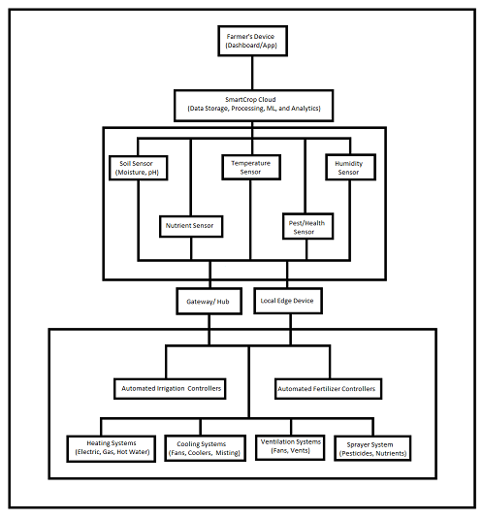

**Explanation**

1. **Farmer's Device**: Access to SmartCrop’s dashboard or mobile app for real-time monitoring and control.
2. **SmartCrop Cloud**: Central data processing, storage, and analytics hub which integrates sensor data, performs machine learning analysis, and sends control signals for automation.
3. **Sensors**:
   * **Soil Sensors**: Monitor soil moisture, pH, and nutrient levels.
   * **Temperature and Humidity Sensors**: Track environmental temperature and humidity.
   * **Pest/Health Sensors**: Detect pests and plant health issues.
4. **Gateway/Hub**: Aggregates data from sensors and transmits it to the cloud.
5. **Local Edge Device**: Performs initial data processing and ensures real-time control.
6. **Automated Controllers**: Manage the operation of irrigation, fertilizer, heating, cooling, and ventilation systems.
7. **Sprayer Systems**: Automatically apply fertilizers, pesticides, and nutrients based on data-driven recommendations.

By integrating these sensors and automation systems, SmartCrop can effectively monitor and optimize polyhouse farming conditions, leading to improved crop yields and resource efficiency.

### 9.2 Abstract

SmartCrop is an AI-driven platform designed to optimize polyhouse farming by leveraging IoT sensors, predictive analytics, and machine learning models. The solution aims to improve crop yield, enhance resource efficiency, and reduce operational costs.

The data from the sensors are transmitted to the cloud and updated in the user-dashboard in real-time. So that the user can be alert if there are any anomalies to be noticed. I will be using LoRaWAN or mesh network for the areas with low internet connectivity in the rural areas. For there to be no delays in the transmission of the data we will use local edge network. We will process the data and gain insights and automated actions will be taken accordingly.

All the devices will be powered by Solar panels or will be battery-powered. So that there will be no problem of power shortage or power cut-off. We will be using data pre-processing pipelines for cleaning data and machine learning algorithms to forecast yield, disease detection using image recognition and resource optimization. And will be using AI Algorithms for predictive and prescriptive analysis for forecasting impacts on crops due to environmental changes and actionable recommendations for farmers.

User Interface should be intuitive and simple visualizing key metrics and trends using dashboards or mobile application. Generating reports based on that analysis.

**10. Conclusion**

SmartCrop leverages the power of Data Science, Machine Learning, and AI to transform polyhouse farming. By providing real-time monitoring, predictive analytics, and resource optimization, SmartCrop empowers farmers to achieve higher yields, reduce costs, and adopt sustainable practices. Our innovative solution positions itself as a game-changer in the agricultural industry, offering immense value to small and medium-sized polyhouse farms.

**Business Model:-**

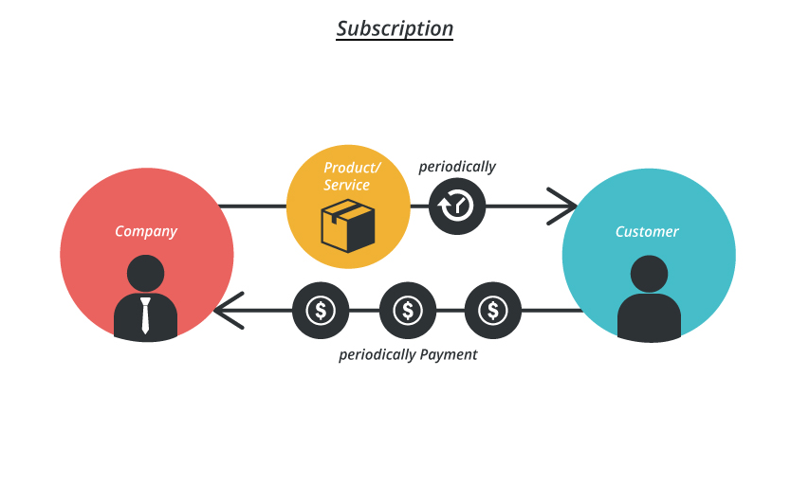

**Financial Equation: -**

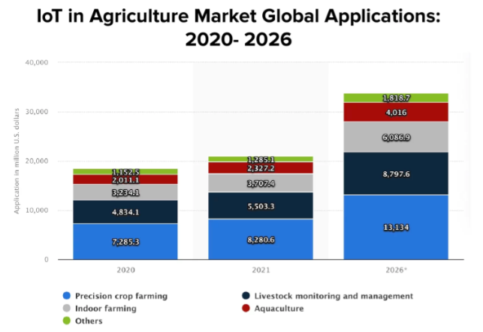

*Source: Statista*

The use of automation and IoT is increasing in the future.

Let,

Total profit = **y**

Price of the product = **1000**

Total rate as a function of time = **x (t)**

Total Production and maintenance cost = **c**

The cost will be the salary of the development and maintenance team. The development team will itself be the maintenance team in the later stages of the project.

So for development of this platform we will need 2 ML Engineers (Let their Salary be ML) and a Full Stack Developer (Let their salary be FS), For Storage and analysis we will be needing Cloud Technology which will cost us (Let’s say) CT.

So the cost for production and maintenance will be **c = 2*ML + FS + CT**

The monetization idea primarily will be through Monthly Subscription which will be 3000 per month.

Therefore, ***y = 3000 * x (t) – (2*ML+FS + CT)*** will be the financial equation.